**SERVICE MANUAL**

***Flow Diagram***

**DM OFFICE SECTION**

*Employer*

**1. Employer registers their organization and submits their requirement of labour (No, skill set).**

**2. Short Fall.**

**3. Application approval.**

API-1 Call to save the detail in database

**DM OFFICE SECTION**

**4. Allotment of labour to employer and generating certificate**

API-2 Call to search for labour and update related tables

*Employer*

END

1. **LOGIN WITH DEFINER LOGIN AND SELECT CREATE NEW SERVICE.**

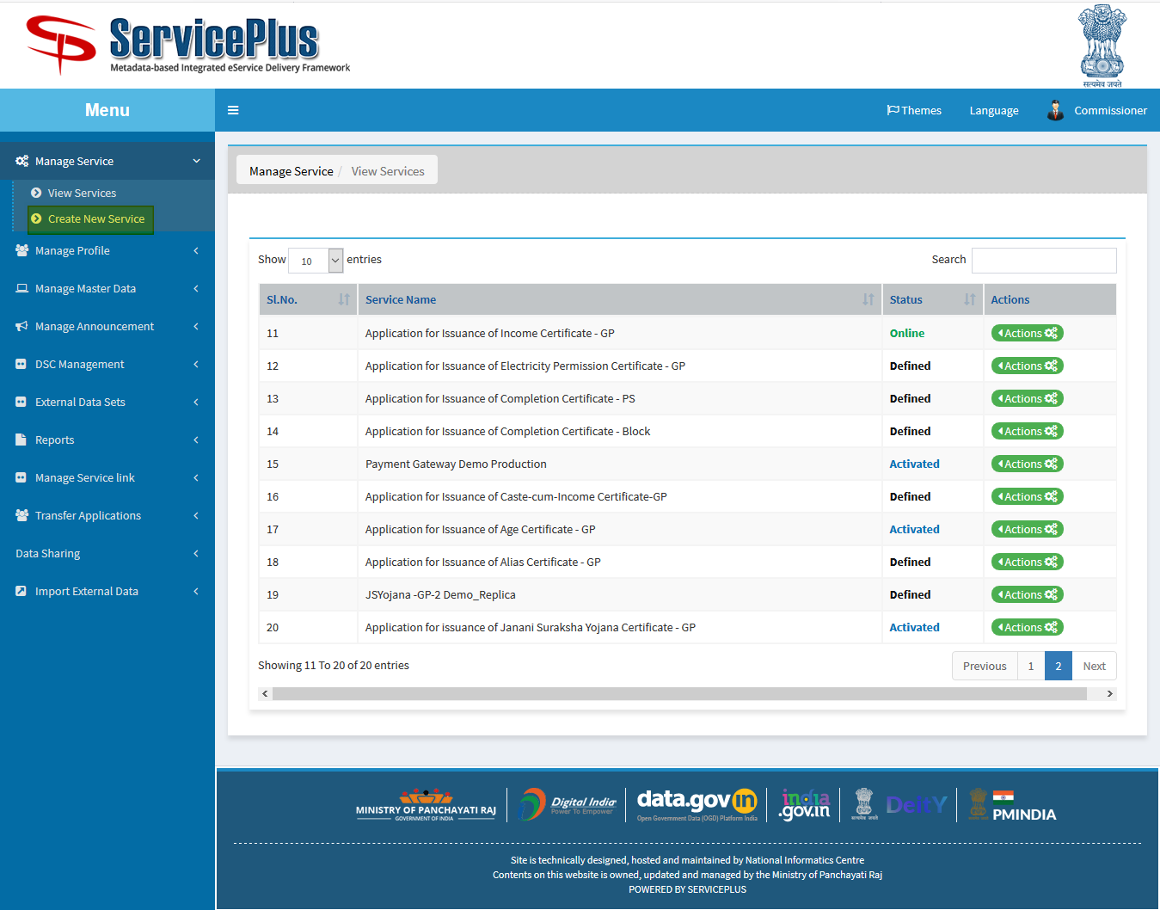

1. **SELECT DEFINITION AND FILL ALL DETAILS.**

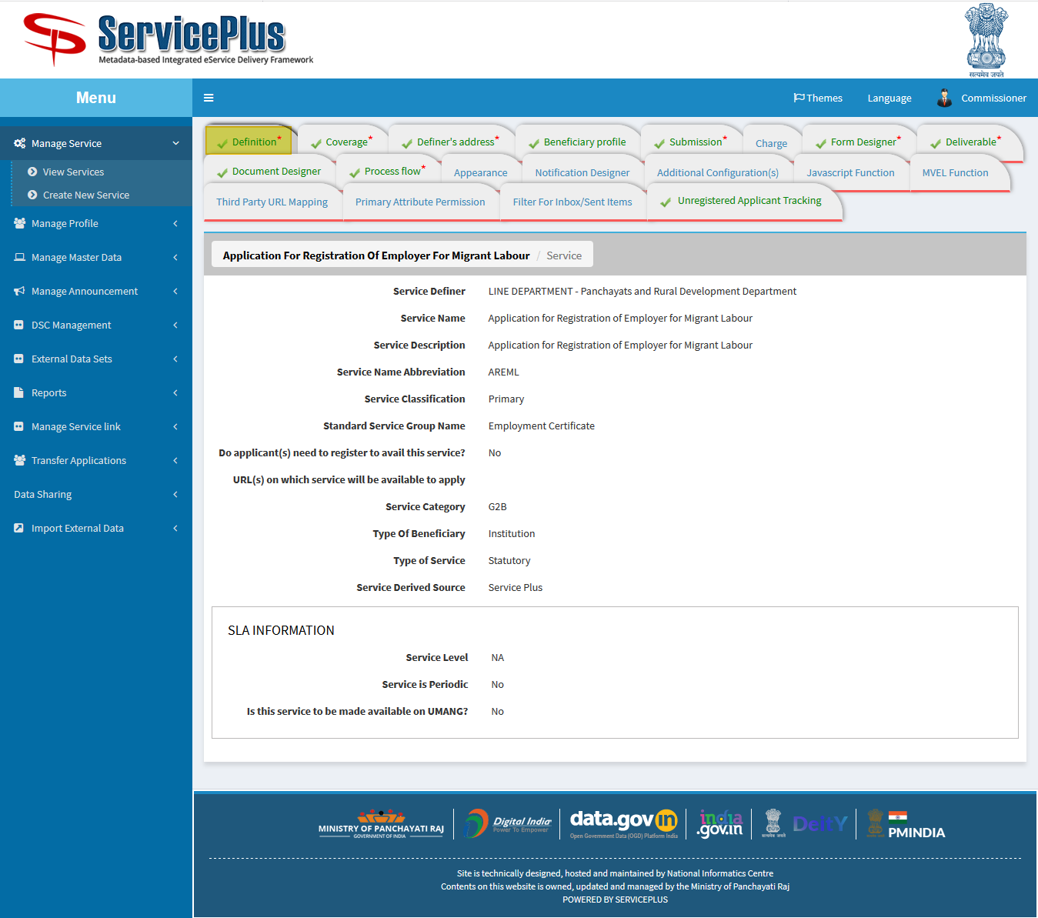

1. **SELECT COVERAGE AND SELECT THE LIST OF SERVICE UNITS.**

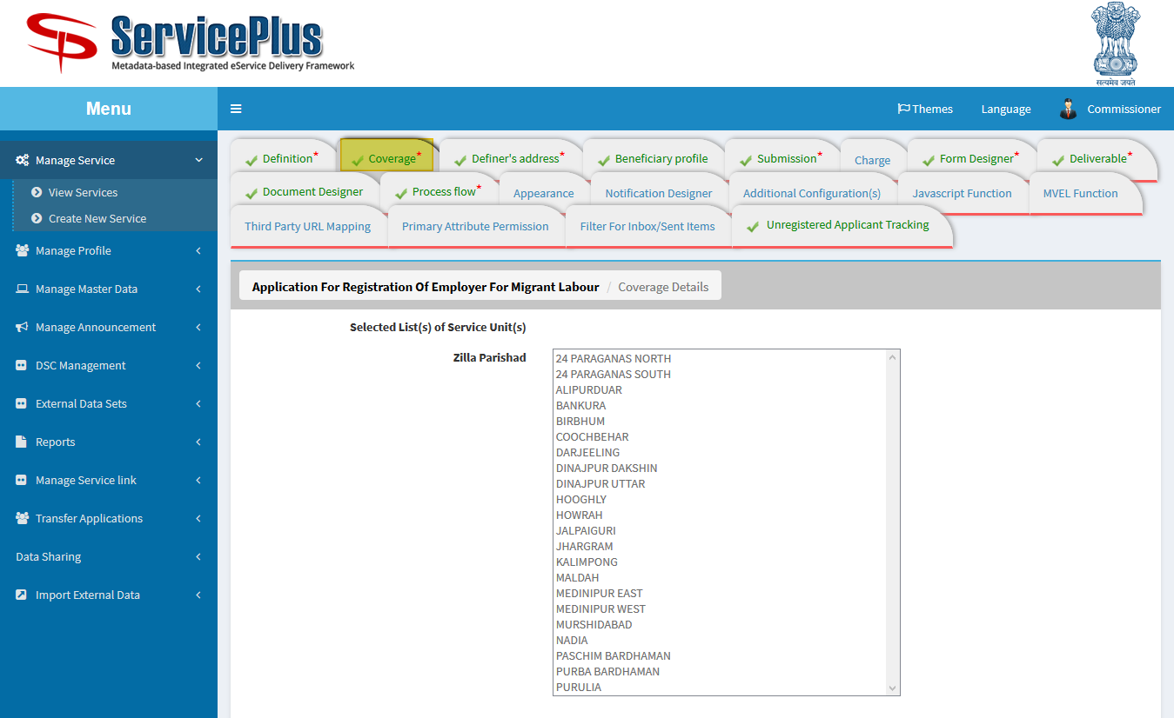

1. **FILL DEFINER’S ADDRESS.**

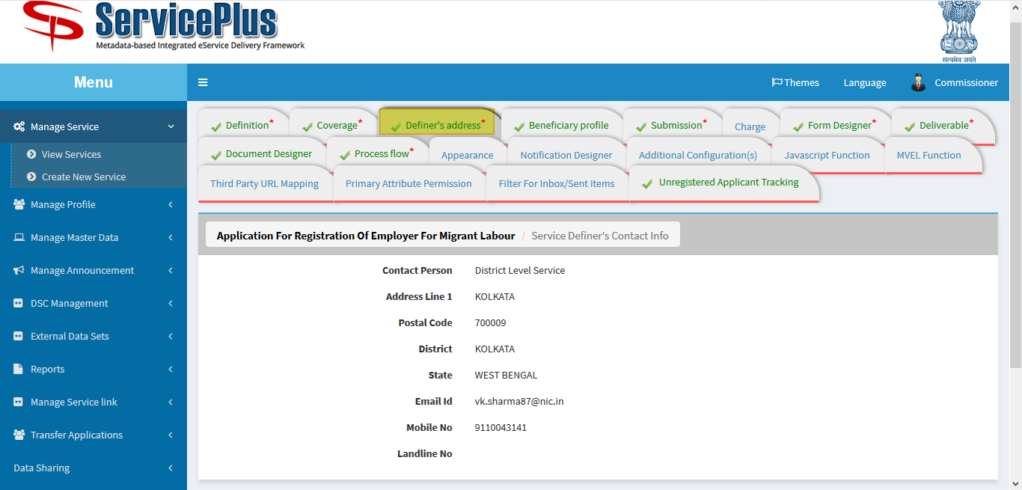

1. **BENEFICIARY PROFILE FOR WHO CAN APPLY.**

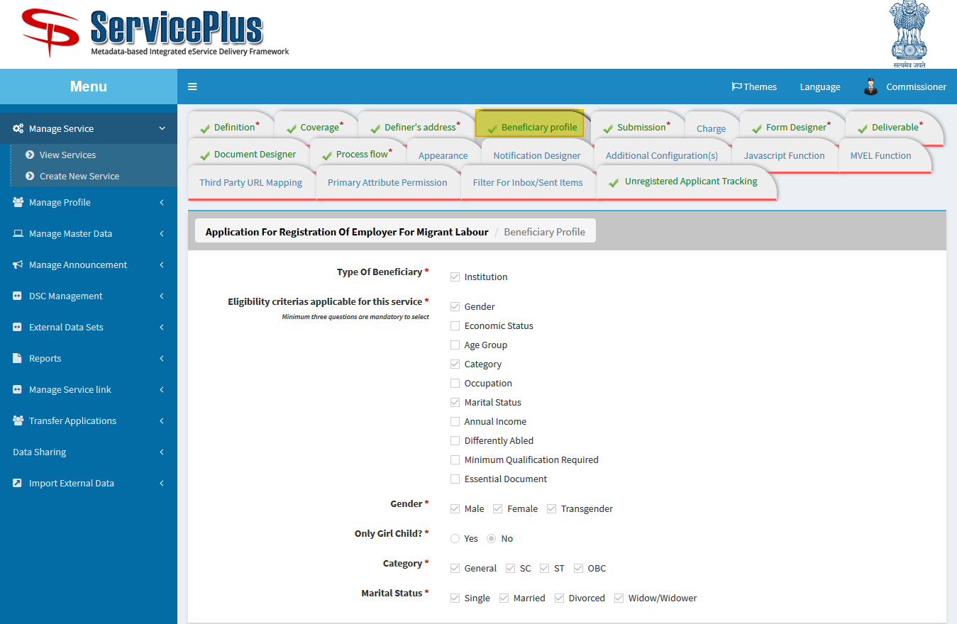

1. **SUBMISSION**

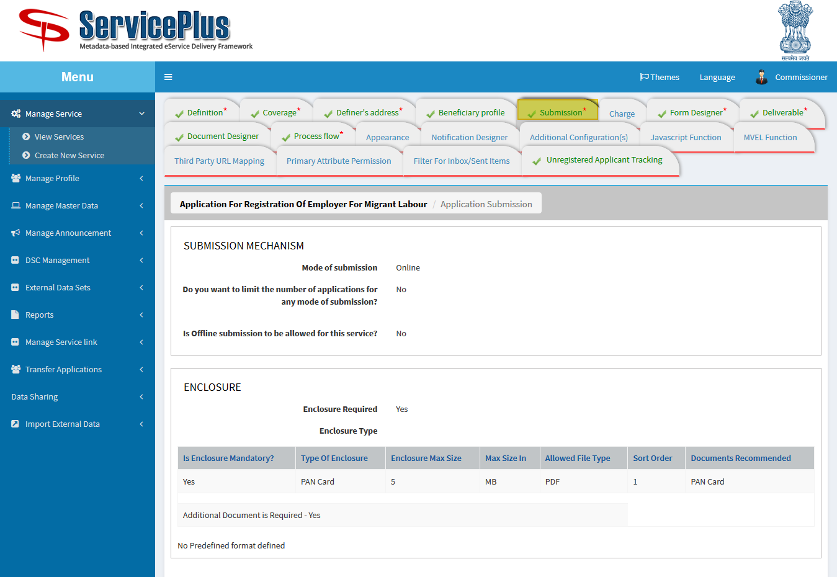

1. **FORM DESIGNER: HERE NEW TEMPLATE FOR FORM CAN BE DESIGNED, MODIFIED OR PREVIEWED.**

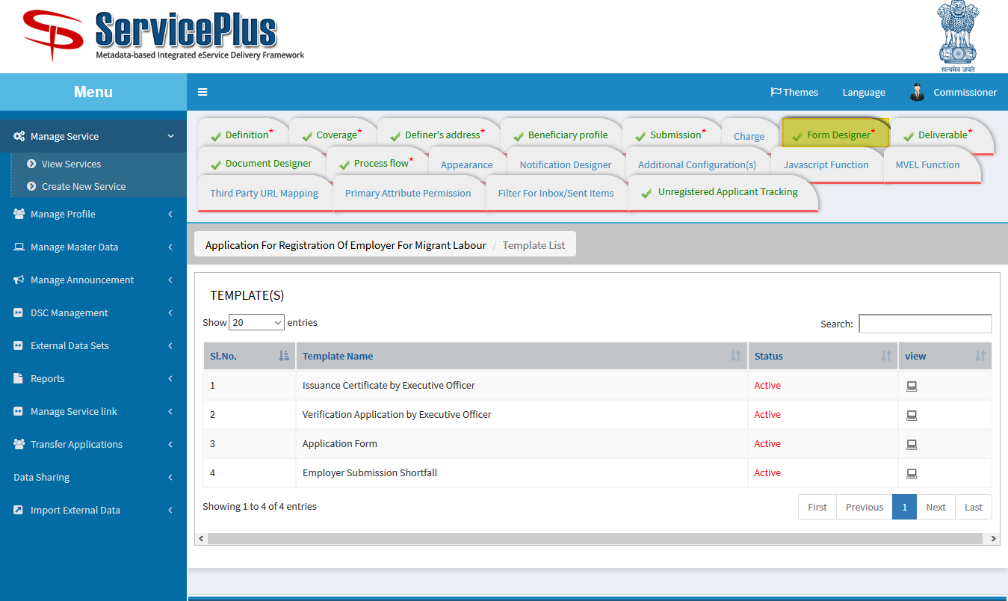

**APPLICATION FORM DESIGN.**

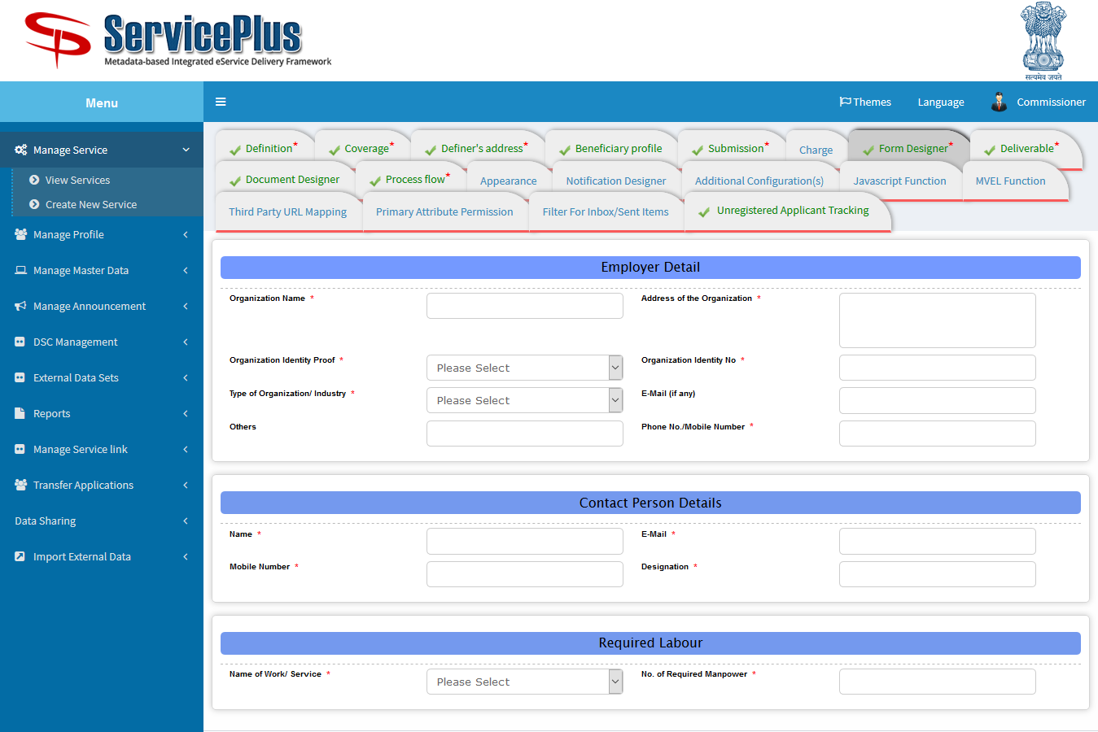

**Verification Application by Executive Officer** 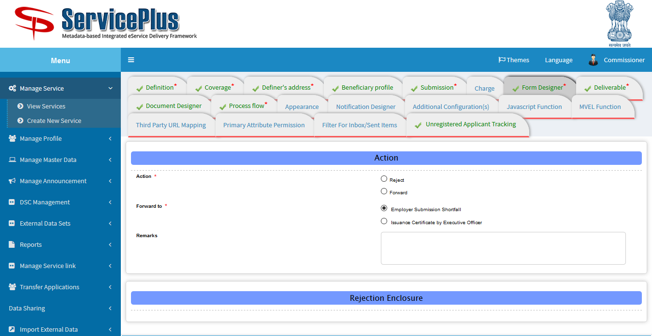

**Issuance Certificate by Executive Officer**

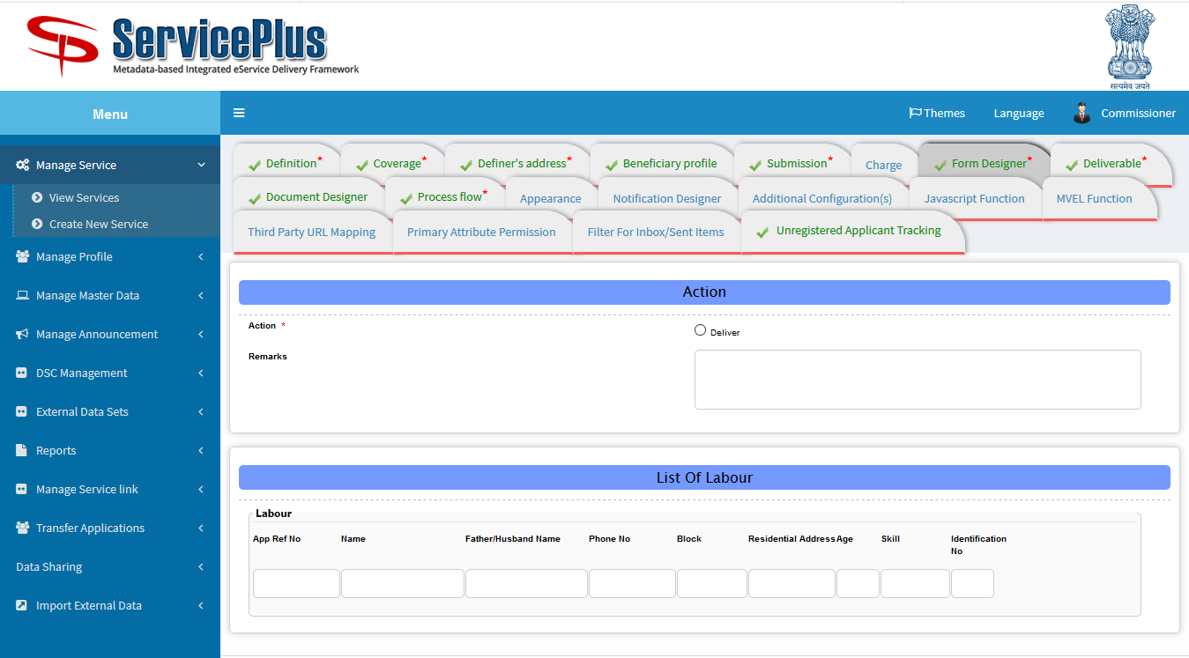

1. **DELIVERABLE: HERE CONFIGURATION IS DONE FOR APPLICATION WHEN IT’S DELIVERED.**

**CERTIFICATES AND BARCODE COULD BE SELECTED TO BE IMPRINTED ON CERTIFICATES.**

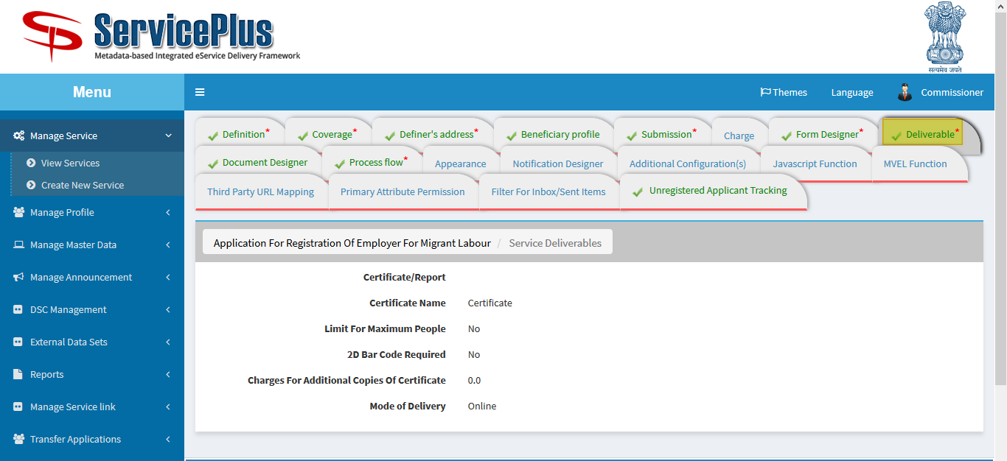

1. **DOCUMENT DESIGNER: DOCUMENT CAN BE DESIGNED HERE.**

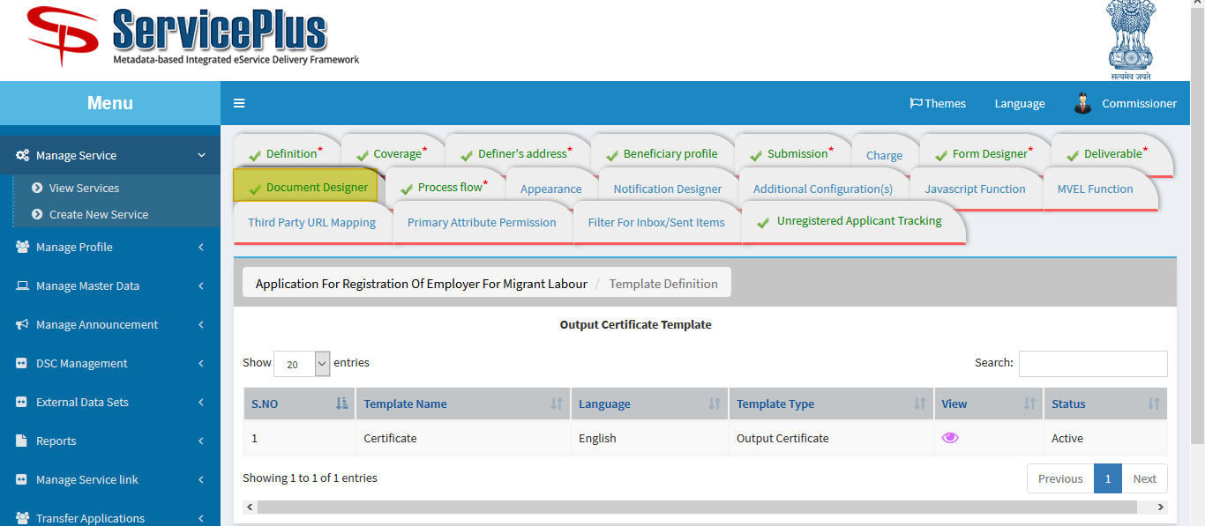

1. **PROCESSFLOW: ASSIGN DEPARTMENT/DESIGNATON FOR DEPARTMENT PURPOSE WHO IS GOING TO TAKE ACTION.**

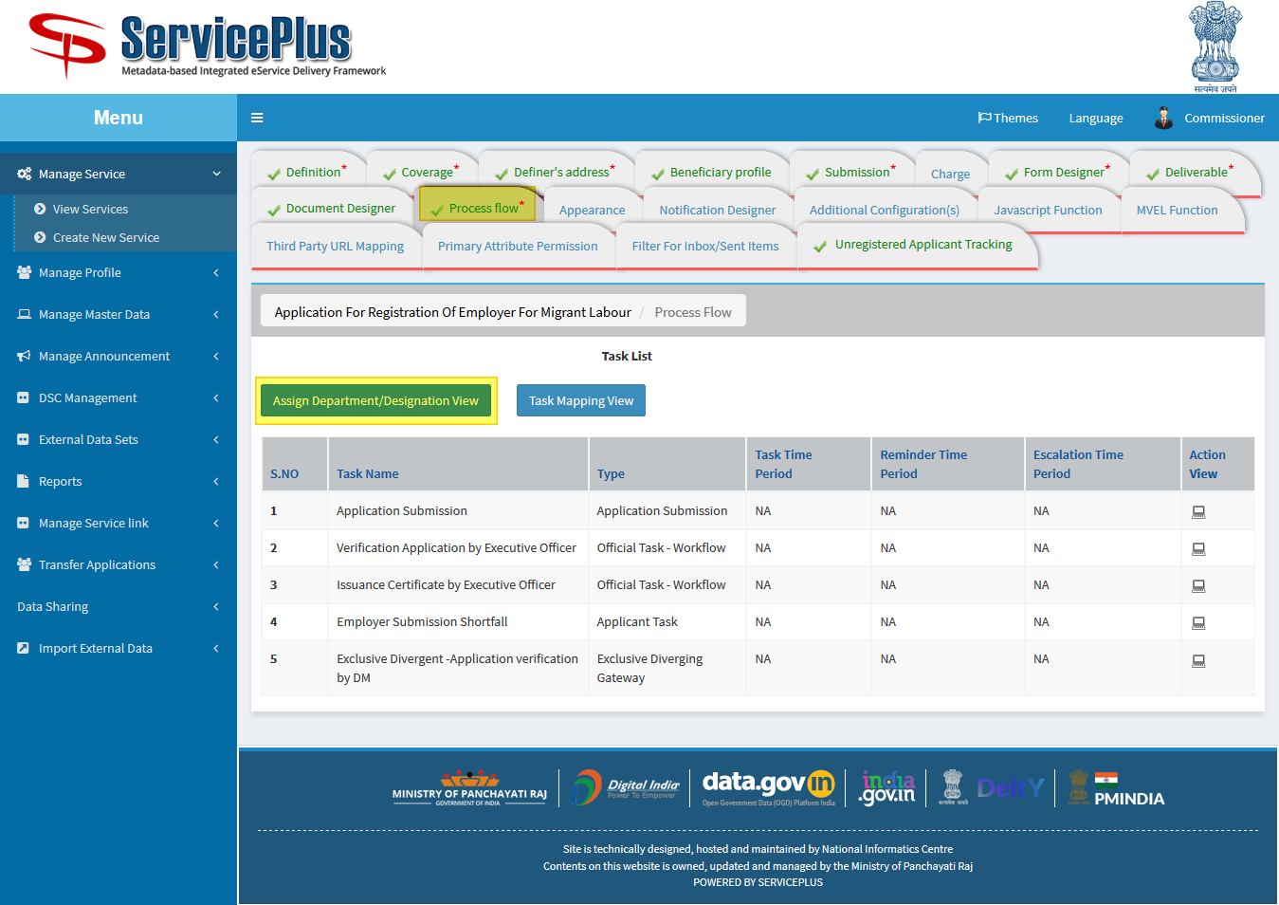

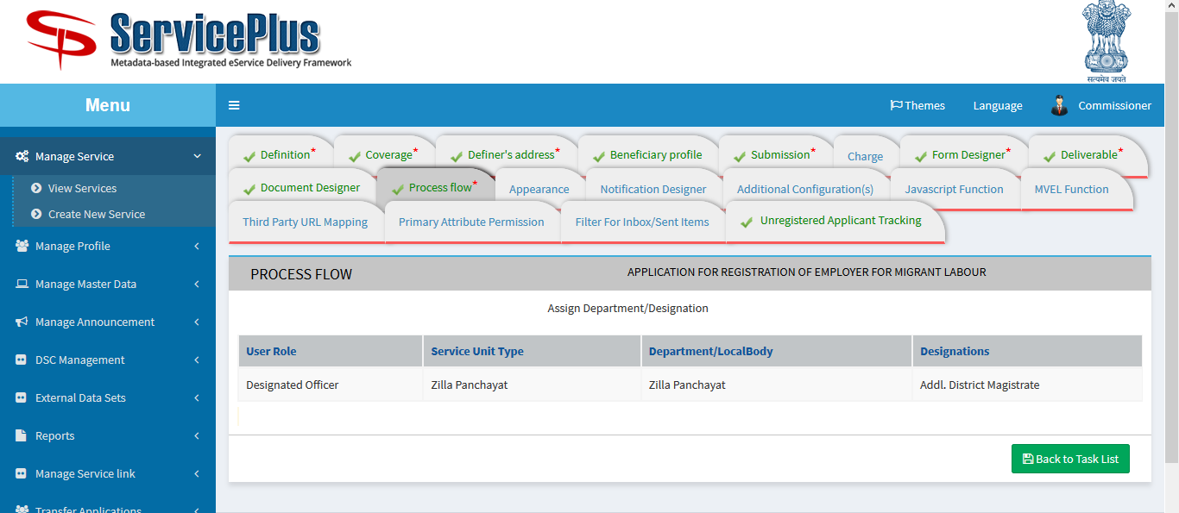

1. **TASK MAPPING VIEW: HERE TASK MAPPING COULD BE SEEN.**

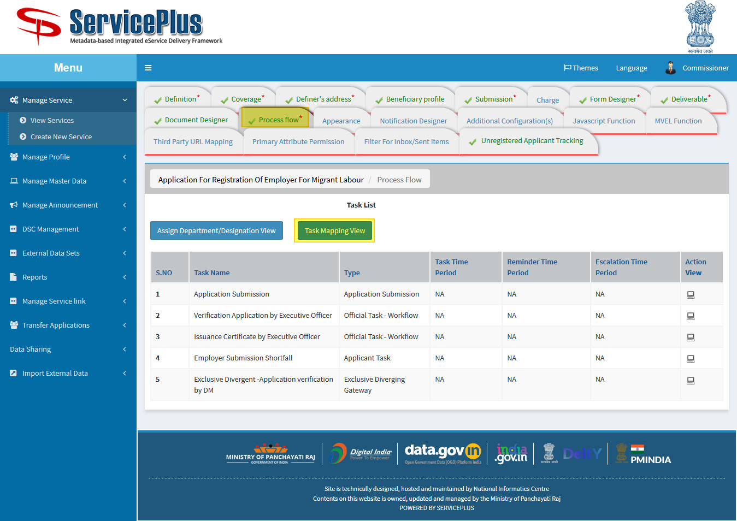

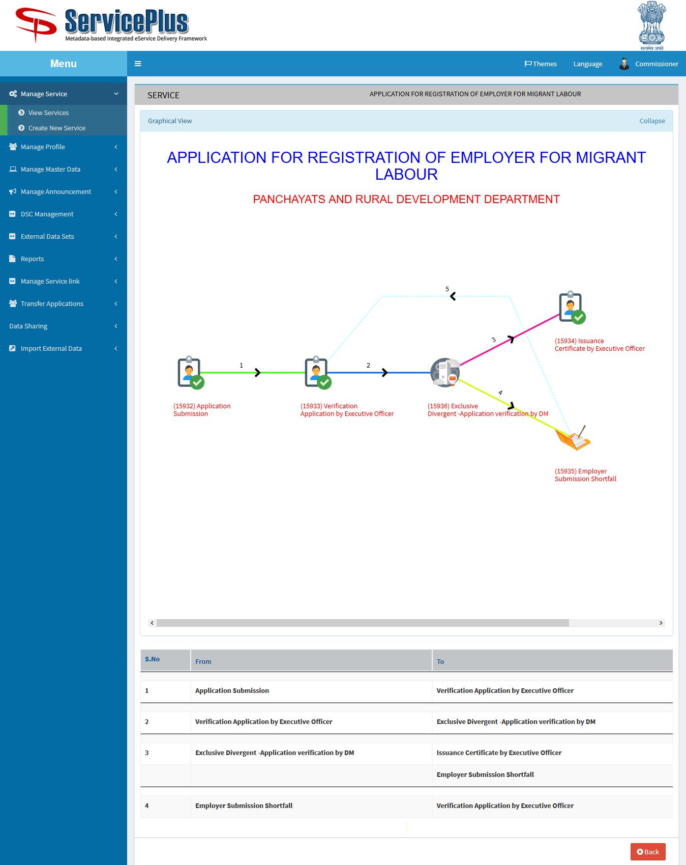

1. **JAVASCRIPT FUNCTION: TO MAKE FORM DYNAMIC HERE JS FUNCTION CAN BE ADDED.**

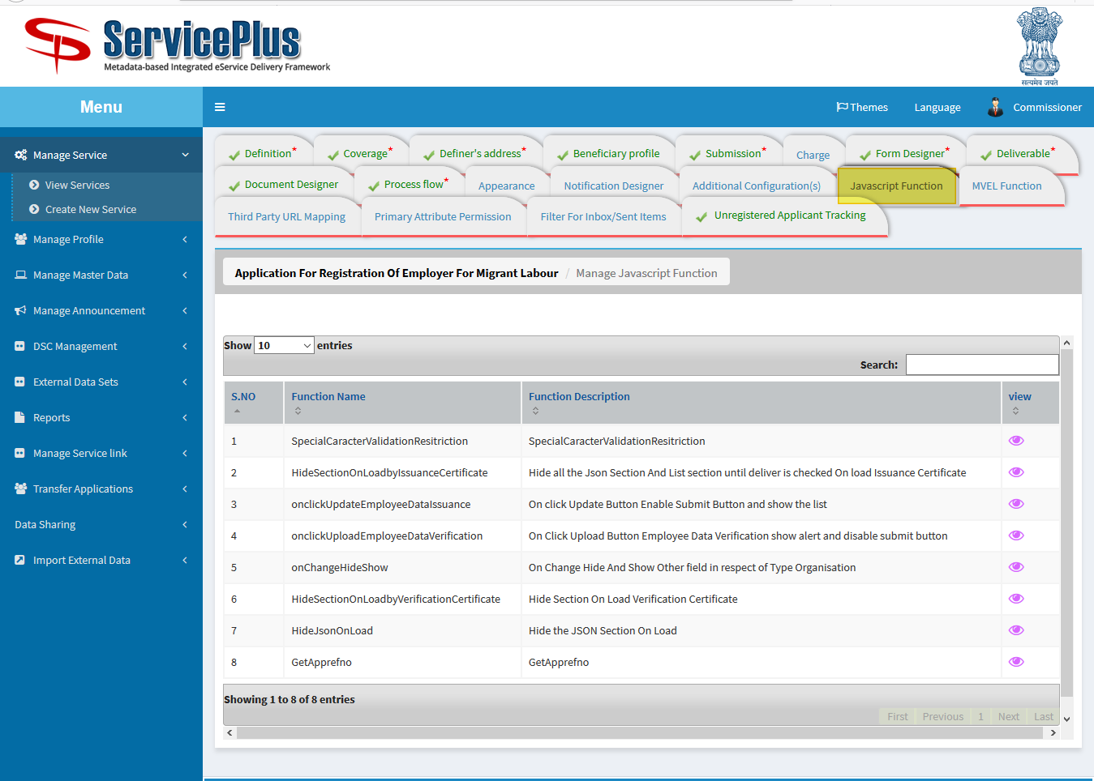

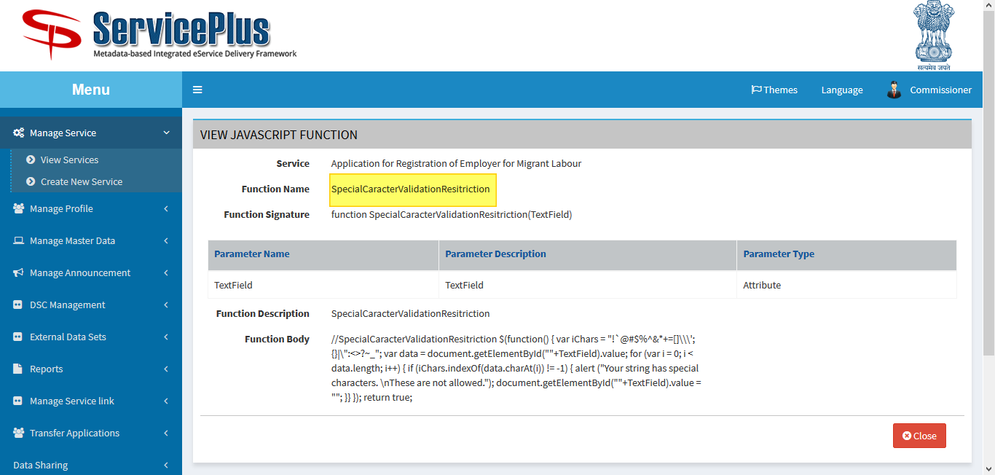

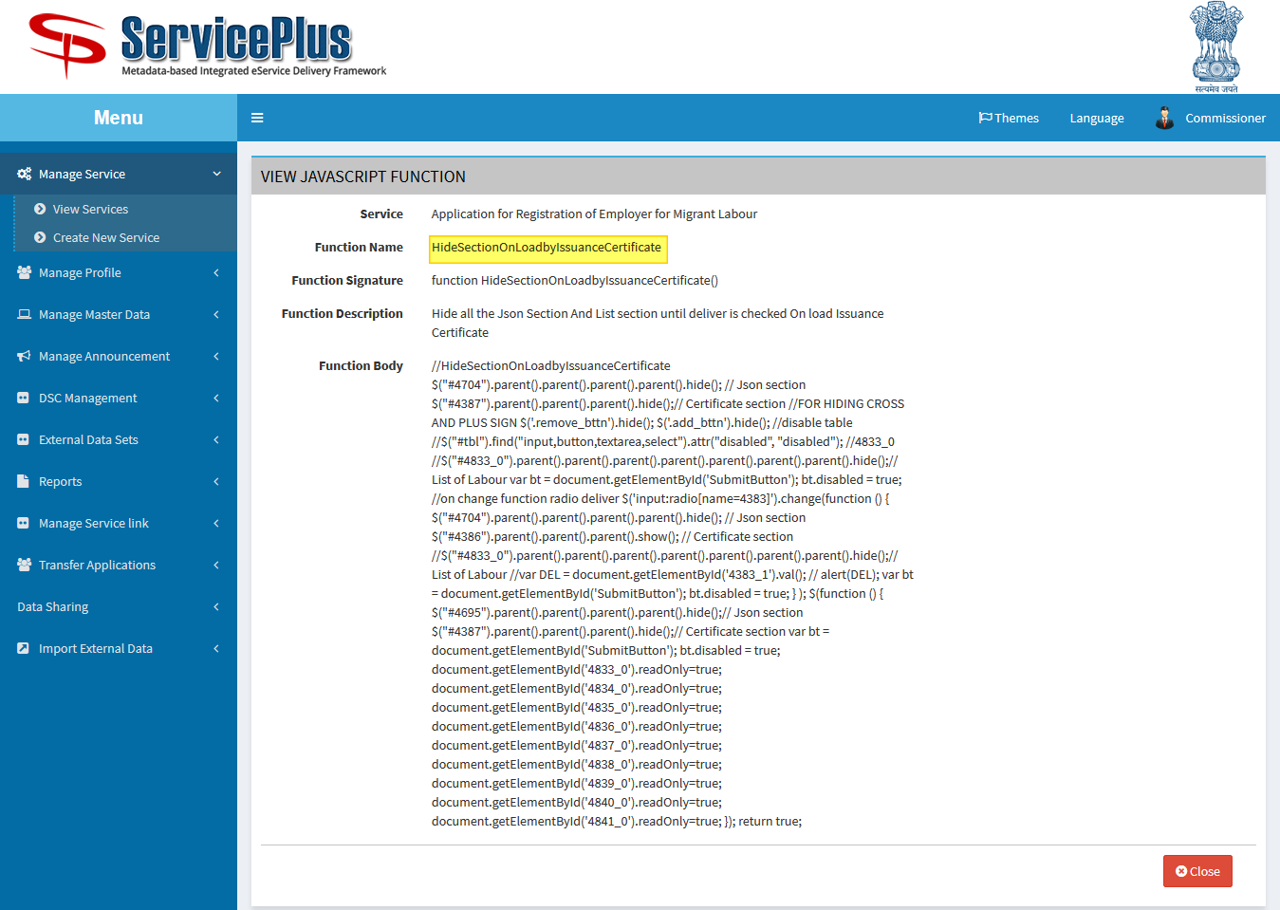

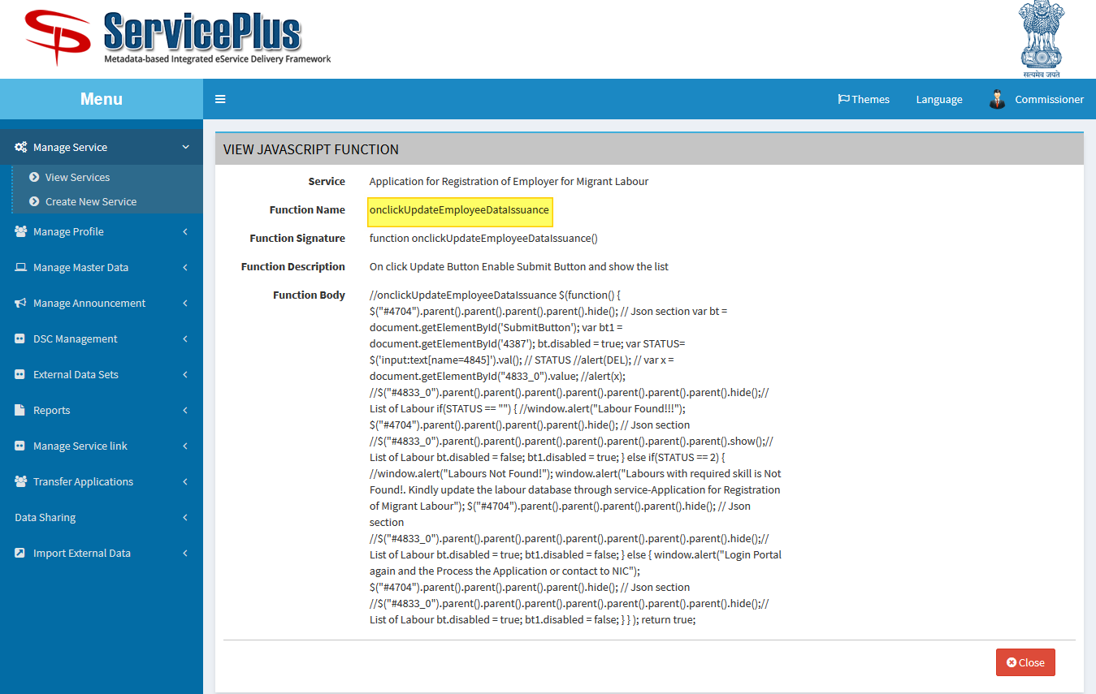

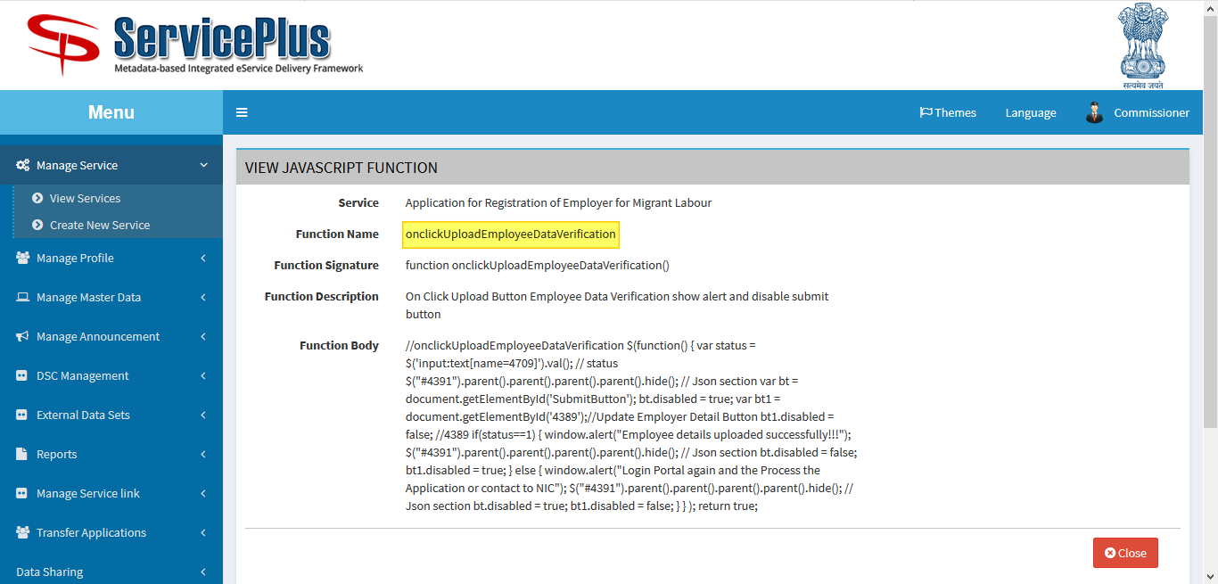

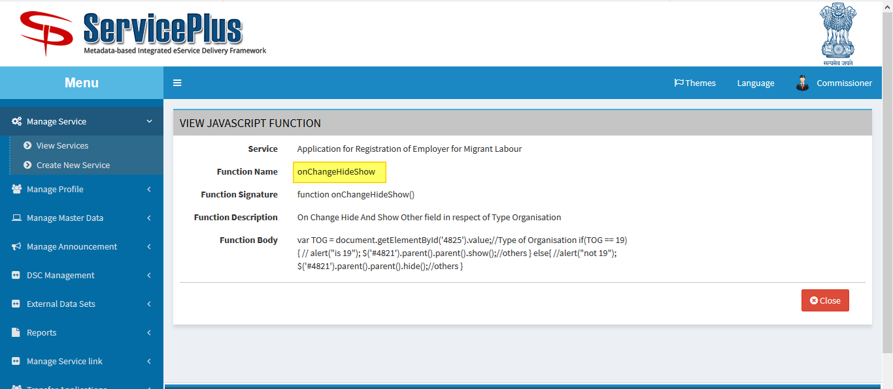

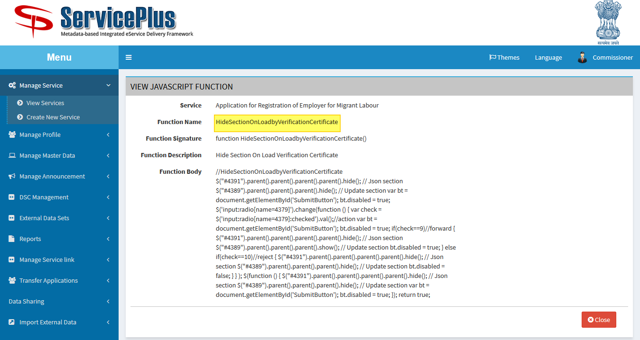

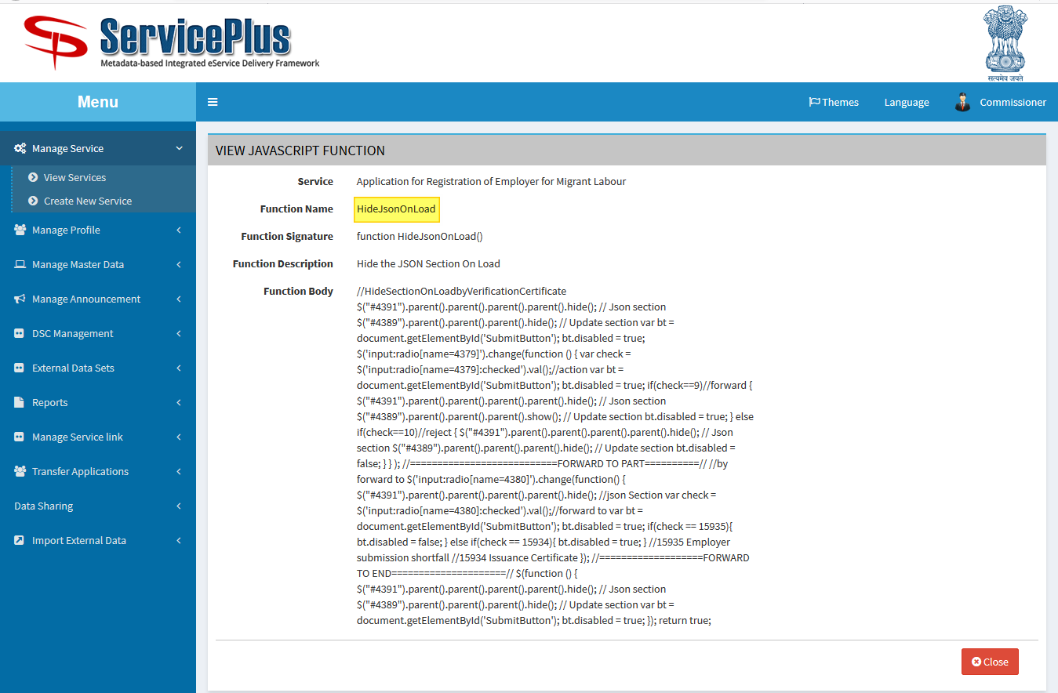

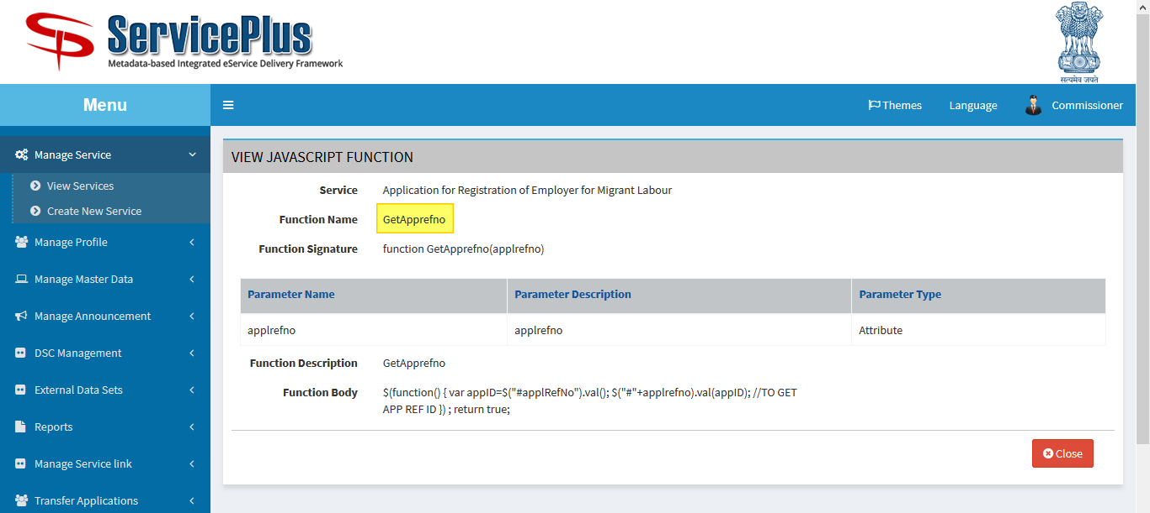

1. **UNREGISTRED TRACKING**

